CONCRETE

COMPRESSIVE STRENGTH

PREDICTION

WIREFRAME DOCUMENT

Shailendra Sahu

Home page

Home page consists of single page having two input sections. The page is designed in such way that user gets two options to get the result.

Option one is "Custom File predict", in this option user can give path of the files for which they want to make predictions.

Option two is "Defaulf File predict" in this option the predictions are being made for the files kept on a default path.

This is how Home page looks like:-

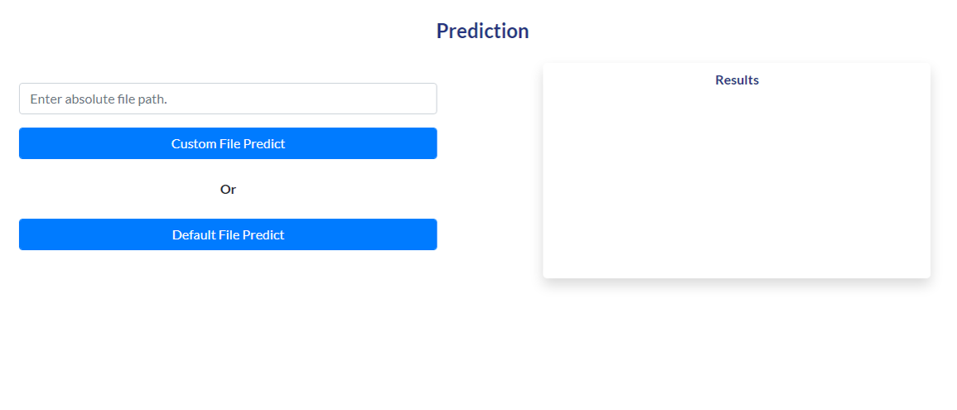

After selecting any of the above options and submitting, the following page opens –

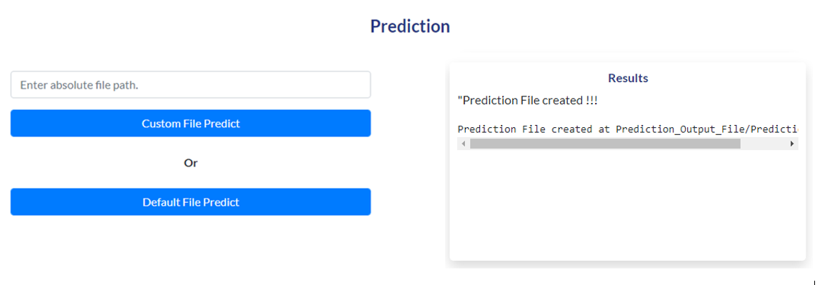

In the “Results” section, it is saying that prediction file is created at a predefined location in csv format.

User can go to that location and check for the file containing prediction results.